How to Generate a Comprehensive Final Inspection Report in SiteManager

- Make sure the “Comprehensive Final Inspection Report” key date is entered by the Section Engineer. Note 1: If the key date is not entered or the key date is deleted, the comprehensive final inspection report will give you error messages. Note 2: The Comp. final inspection report tells the contractor that he/she has 90 days from the key date to finish the corrective work, unless otherwise modified by the Engineer.
- Log in as ROS/ROM
- Click on “Contract Administration”
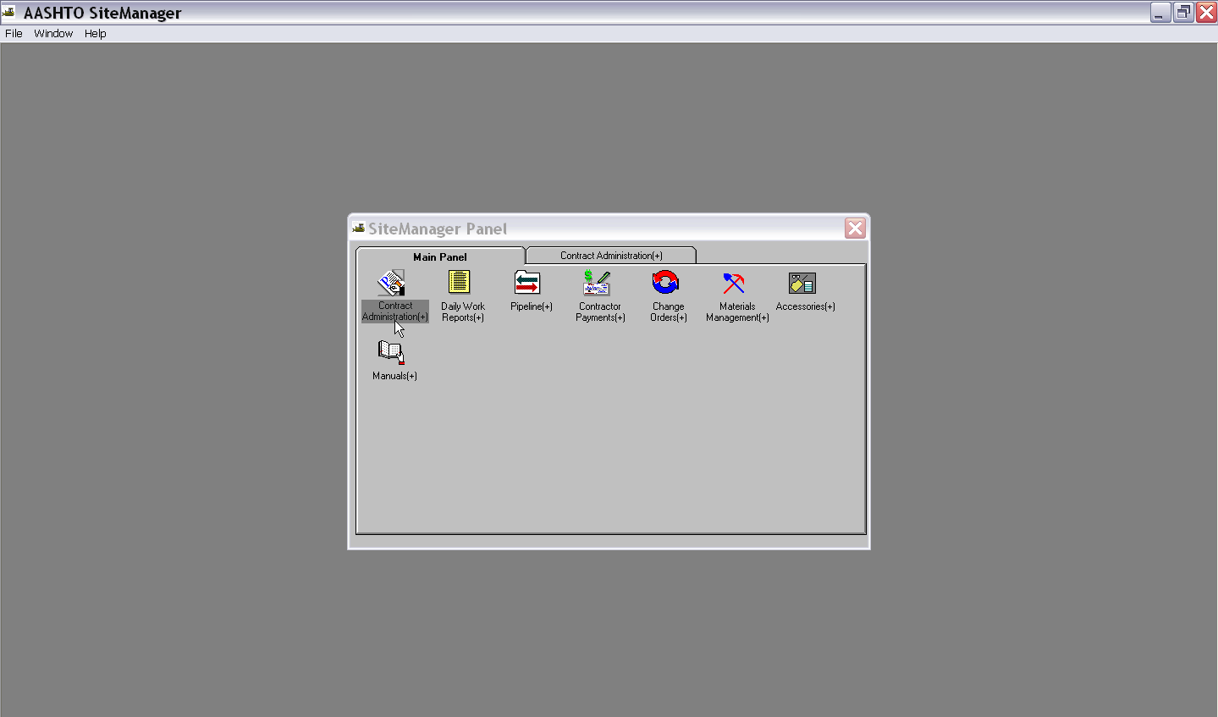

- Click on “Process List”
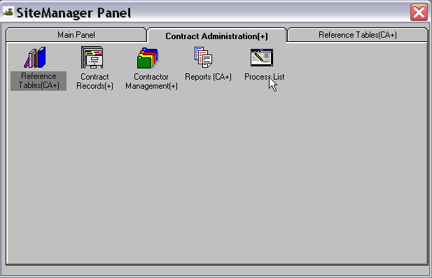

- Click on Process ID “FCI”
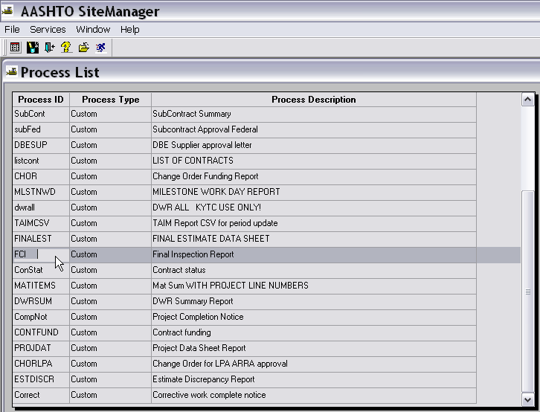

- In the “Confirm Process Submission” box, the Section Engineer’s name should be typed in the “Inspector” box, the “Comprehensive” box should be changed from “No” to “Yes,” and any inspections that were required for the project should be changed from “No” to “Yes.” Note: any item not marked no will have its key date shown in the comprehensive report.
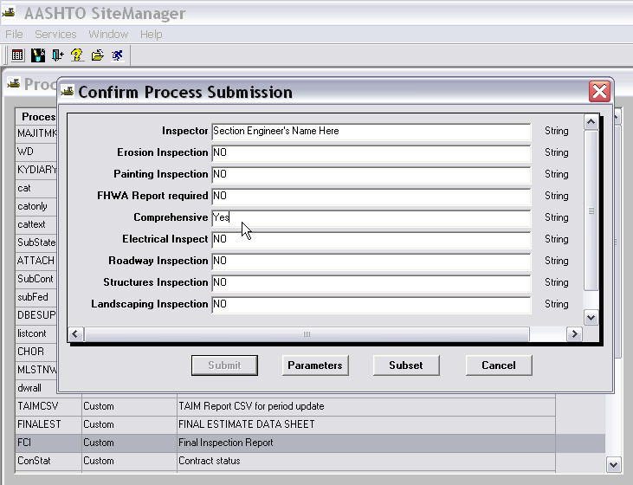

- Click the “Subset” button.
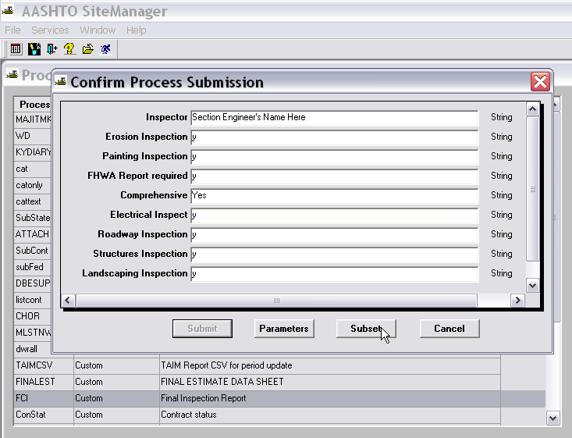

- Choose your Contract and click “ok”
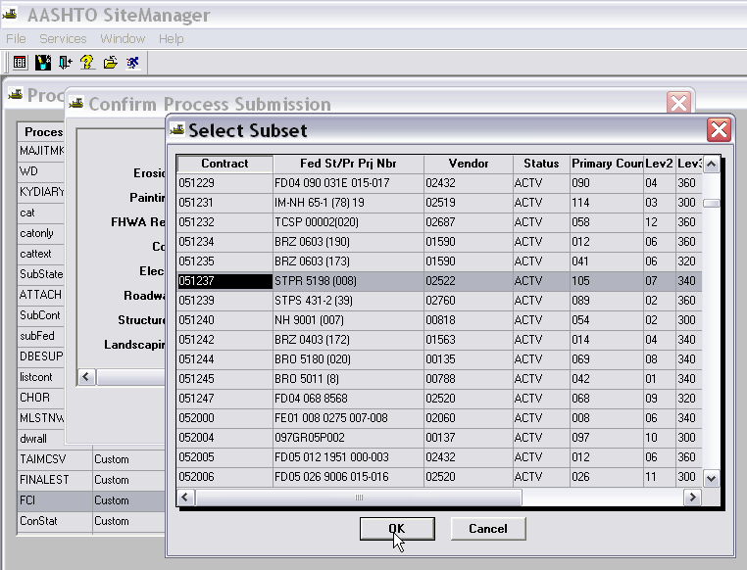
- Click “Submit”
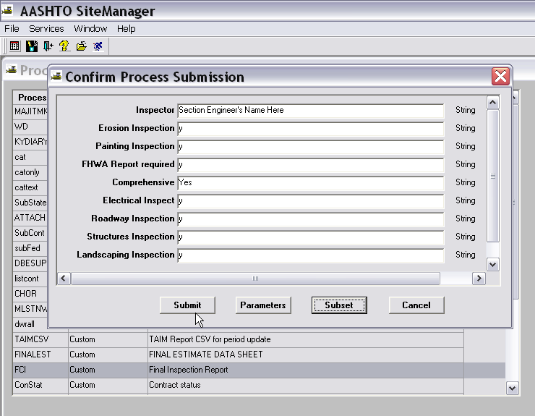

- Once submitted, treat like an Estimate. When the process completes, click on “Services” then “Process Status.” Choose the FCI that you just ran then double click on the “Output.html.”

- Save your Comprehensive Final Inspection Report as .doc or .docx file to your desktop. If you can’t do that, save it as a text file but note that if you save it as a .txt file that you need to add .RTF to the end of the file name to make sure what you save looks like a readable report.
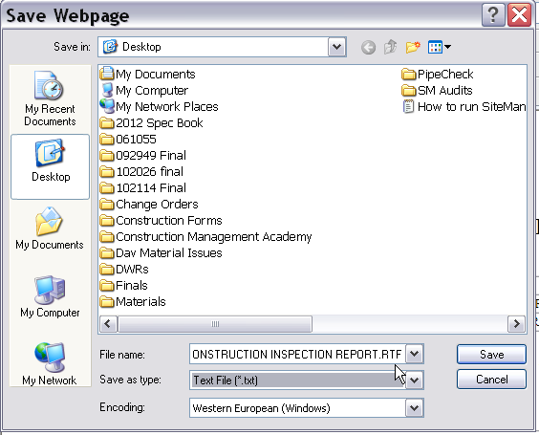

- Note that no punchlist items show up in the report. That’s b/c we never put punchlist items in SiteManager. Go gather your final inspection reports that you’ve received for this project. If you have them in a Microsoft Word file, even better.

- At this point, you need to open the report that you just saved and put your punchlist items under the “Comments” section of the report. If your final inspection reports are in a word file, copy and paste. If not, attach other report forms to the comprehensive final inspection report.

- Mail the report to the Contractor immediately and put a copy of the report in Projectwise.

