Instructions & Guidelines for the Contractor’s Performance Evaluation

POLICY STATEMENT:
The Kentucky Transportation Cabinet requires that a Contractor’s Performance Report form (TC 14-19) be completed for every Prime Contractor for each project annually or at project completion. Additionally, the evaluations will be performed on the same basis for all Subcontractors performing over $50,000 of work during the evaluation period or as requested by the subcontractor or deemed necessary by the project engineer. Evaluations shall be performed in an objective, consistent, and well-documented manner. The Contractor’s average performance rating (weighted by dollar amount of work performed) for the previous year will be used in the calculation of the Contractor’s Maximum Eligibility Amount. Utilizing the scores from the Contractor’s Performance Report will provide incentive for the Contractor to consistently perform at a high level of quality.

SCOPE:
Every Contractor or Subcontractor shall be furnished a copy of the completed Contractor’s Performance Report for every project for which work and an evaluation has been performed. In the event of multi-year projects, evaluations will be completed at the end of each year, as well as at the end of the project and a copy will be sent to the Contractor(s).
For projects completed within one calendar year, a Contractor’s Performance Report shall be completed for every Prime Contractor and Subcontractors performing over $50,000 of work on the project. For multi-year projects a Contractor’s Performance Report shall be submitted for the Prime Contractor and Subcontractors performing over $50,000 of work within the evaluation period. Each performance evaluation will represent the quality of the Contractor’s performance during the previous time period.
If a Subcontractor performs less than $50,000 of work within a calendar year, it is not necessary to complete a Contractor’s Performance Report for that given year. Any subcontractor who has not achieved the threshold warranting an evaluation, may request a performance evaluation. Also, the project engineer may elect to complete an evaluation for a subcontractor even when one has not been warranted by the value of work completed. These evaluations will be weighted and regarded in the same manner as those required once submitted.

RESPONSIBILITIES:
The Contractor can obtain a blank copy of the Contractor’s Performance Report (TC-14-19) at transportation.ky.gov/construction. This form will provide the Contractor an example of what he/she is being evaluated on during the project. Additionally, the Section Engineer must download the most up-to-date version of the form from transportation.ky.gov/construction prior to completing the evaluation.
A Contactor’s Performance Report will be completed at the completion of every project once all work has been completed (including punch lists, final clean up, etc.), to reflect the quality of the Contractor’s performance on the given project.
For projects spanning more than one calendar year, the Section Engineer must complete and submit Contractor Performance Reports for all current projects by December 31st of each calendar year.
Once an evaluation has been completed, the Section Engineer will sign and date the evaluation. A copy of the signed evaluation is then sent electronically, or in paper copy, to the evaluated contractor with an appeal application included. Copies should also be forwarded to the applicable TEBM for Project Delivery and Preservation and to the Chief District Engineer (CDE). Upon expiration of the appeal deadline, the TEBM will send a copy of the signed evaluation to the Division of Construction Procurement.

COMPLETING THE CONTRACTOR’S PERFORMANCE REPORT:
Use form TC14-19 under the Division of Construction Procurement at the following link: http://transportation.ky.gov/Construction/Pages/Contractors-Performance-Evaluation-Report.aspx.
Instructions for completing the form are found under the heading, “Using the Contractor Evaluation Template,” below.

TIMELINESS:
For “end-of-project” evaluations, the Section Engineer has ten (10) business days to submit the completed Contractor’s Performance Report to the contractor.
For projects spanning one calendar year, and “annual” evaluation is required, The Section Engineer is responsible for seeing that the “end-of-year” evaluations are completed and submitted to the contractor by the December 31st of that year.

Reports should be forwarded to the following address:
Kentucky Transportation Cabinet
Division of Construction Procurement
Attn: Cherie Shelton
200 Mero Street, 3rd Floor
Frankfort, Kentucky 40622

APPEALS PROCESS:
An appeal form (TC 14-20) shall accompany every completed Contractor’s Performance Report that is sent to the Contractor. This appeal form will give the Contractor the opportunity to object to a given rating by explicitly detailing the cause for the objection. The appeal form can be obtained at the following website http://transportation.ky.gov/Construction/Pages/Contractors-Performance-Evaluation-Report.aspx. The Contractor has ten (10) business days to submit the completed appeal application with the original Contractor’s Performance Report to the CDE.
It is the responsibility of the CDE to address the appeal within ten (10) business days upon receipt of the appeal, and to settle the matter between the Section Engineer and the Contractor. The ruling on the appeal will be conducted at the district level, and the final Contractor’s Performance Rating will then be sent to the Division of Construction Procurement.

PREQUALIFICATION COMMITTEE:
The Cabinet’s Prequalification Committee will use the information collected from the Contractor’s Performance Reports completed throughout the year to assist in determining a Contractor’s maximum eligibility amount. During this process, the committee may review individual Contractor Performance Reports for clarification or justification.

Using the Contractor Evaluation Template
- Prior to opening the template, the following project information should be collected for completing the evaluation. There are two types of evaluations: the project completion evaluation or the year-end evaluation. Collecting the information will prepare the evaluator for answering the evaluation questions for each contractor (prime and subcontractor) on the project according to your applicable evaluation type.
Project Completion Evaluation (Section 1)
- What amount of work was removed/replaced and/or what amount of deductions were assessed?
- Was a Section Engineer’s punch-list completed prior to final inspection?
- What amount (qualitative-minor, average, major) of corrective work was needed?
- Were there any material deficiencies?
- When was the project complete compared to the scheduled completion date or working days?
- When was corrective work completed compared to the issuance of the Comprehensive Final Inspection Report?
- What level of engagement, scheduling, communication and cooperation was there with KYTC?
- Did traffic control meet standards?
- Was work completed only within allowed hours?
- Were there any work zone incidents?
- Were temporary (eg. flagger, double fine, etc.) signs changed to reflect project traffic control?
- Was there active use of advanced warnings, consideration of Over-Size Over-Weight carriers, communication with media, and onsite traffic technician staff?
- Were there any OSHA citations?
- Were there any hazards noted by the section engineer?
- Were there safety meetings regularly held? Were all project partners invited to safety meetings?
- Were there any EPA fines?
- Was seeding progressively managed according to permits?
- Were any 5-day letters issued?
- Did reseeding occur more than once?
- When was seeding established compared to completion date?
Year-End Evaluation (Section 2)
- What amount of work was removed/replaced and/or what amount of deductions were taken?
- Were there any material deficiencies?
- Were deficiencies addressed in a timely manner?
- Does the project progress appear to indicate the project is behind, on, or ahead of schedule?
- What level of engagement, scheduling, communication and cooperation was there with KYTC?
- Did traffic control meet standards?
- Was work completed only within allowed hours?
- Were there any work zone incidents?
- Were temporary (eg. flagger, double fine, etc.) signs changed to reflect project traffic control?
- Was there active use of advanced warnings, consideration of Over-Size Over-Weight carriers, communication with media, and onsite traffic technician staff?
- Were there any OSHA citations?
- Were there any hazards noted by the section engineer?
- Were there safety meetings regularly held? Were all project partners invited to safety meetings?
- Were there any EPA fines?
- Was seeding progressively managed according to permits?
- Were any 5-day letters issued?

- Opening the Template
The TC 14-19 is a Macro Enabled Microsoft Excel spreadsheet. This means two things: 1) you must enable Macro content and 2) you must save the file with a unique filename.
- To open the file and enable Macro content, simply open the TC 14-19 Template file, preferably from the Division of Construction website (http://transportation.ky.gov/Construction/Pages/Contractors-Performance-Evaluation-Report.aspx). The first time you open the file, a “Security Warning” will appear. Simply click the “Enable Content” button and the file should open and a new window should appear. You will not need to repeat this process if reopening the template on the same computer unless the form is updated.
- If you experience further technical issues in opening the template, security settings may need to be revised on your computer and you should contact the Division of Construction for initial support and next steps.
Click here

- Select from two options:
  - 1) Final Evaluation (Section 1)-select this option when completing contractor or subcontractor evaluations on a project that has been completed.
  - 2) Year-End Evaluation (Section 2)-select this option when completing contractor or subcontractor evaluations on a multi-year project at an interim year-end and progress will continue into the next year.
- Regardless of the type of evaluation, input the Contractor and Project Information.
  - Contractor Name is populated by a dropdown list. You can click the down arrow to search for the name or begin typing the name to refine your search. If you do not find the contractor name, type it in and be sure to self-enter the address and contact information in later steps. Also be sure to let the Division of Construction know of any contractors not found in the dropdown list.
  - Enter the Contract ID, Project County, and again use the dropdown to select the contractor type of sub or prime.
  - Once the information is complete, click “Continue.”

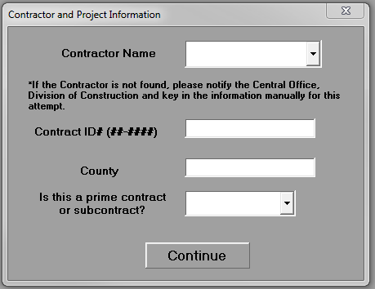
- Select how you would like to complete the form.
  - Using the Wizard-the form wizard walks the user through the evaluation one rating at a time and provides the criteria for selecting each rating (see example below). This method is highly recommended for new users. Key-ins or dropdown menus are used to select a rating.
  - Completing the from manually-manual completion of form is only recommended if the user knows the ratings (according to the selection criteria) for each question and wishes to enter the ratings all at once. Comments in the spreadsheet contain the rating criteria if needed.
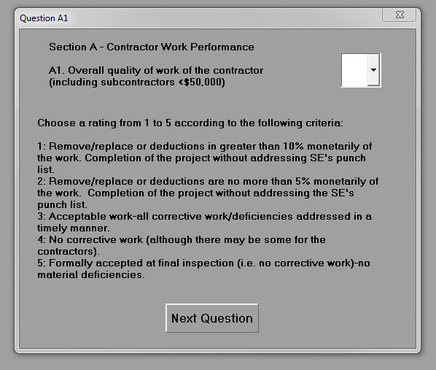
- Using the information from step one, enter the required ratings per the criteria. The last window will request the user’s name, date of evaluation, and any comments. Comments are not meant for justification of any rating, merely for any information the user would like to add.
- Print and sign the evaluation.
- Submit a copy of the evaluation, with an appeal form (TC 14-20), to the Contractor, TEBM and CDE. Upon expiration of the appeal window, ensure the TEBM will send a copy to the Division of Construction Procurement.

Frequently Asked Questions
- Do you have to evaluate all subcontractors?
  - No, only those who performed more than $50,000 of work on the project (Project Completion Evaluation) or within the calendar year on the project (Year-End Evaluation). You may still elect to complete an evaluation even if this threshold is not met. Also, the subcontractor may request for you to complete an evaluation even if they do not meet this threshold.
- Are comments required for certain scores?
  - No, comments are for use at your discretion.
- Is the CDE signature required?
  - No, the CDE should get a copy of the evaluation but is not required to sign the evaluation. The CDE will be involved if an appeal is submitted.
- Will the scores be lower than the previous system?
  - Yes, the previous system postulated a “4” to be average. This system makes a “3” average. The prequalification table which adjusts maximum eligibility has been updated to account for this change.
- What if my contractor is not in the drop-down list?
  - You can still complete the evaluation using the form but you will have to manually enter the name and contact information of the contractor.
- What if I have concerns about the criteria for rating selection?
  - Contact the Central Office, Division of Construction with any criteria questions or comments.

